Student Activity
21 Using electrical meters

TASK
To measure current, voltage or both in a group of simple circuits, and use the measured values to calculate the resistance of a globe.

THEORY
Ammeters and voltmeters are examples of moving-coil meters. The essential difference is in the internal resistance of the meter. An ammeter measures the current in series with the circuit, so its internal resistance is very low: a large resistance would take a large potential from the circuit. A voltmeter measures potential difference in parallel with a component, so it has a very large resistance; this allows current to continue flowing through the component.

EQUIPMENT
• variable power supply
• connecting wires
• two 6 V globes in holders
• DC voltmeter (0–10 V) or voltage sensor
• DC ammeter (0–1 A) or current sensor
• switch

NOTES ON METHOD
Connect circuits A, B, C and D in turn.
Be sure that the positive terminal of the ammeter is connected to the positive side of the circuit.
Also, be careful to ensure that the 1 A terminal of the ammeter is used if the meter has a multiple scale.

For each circuit, close the switch and read the value of the current on the appropriate scale of the meter. Tabulate your results.

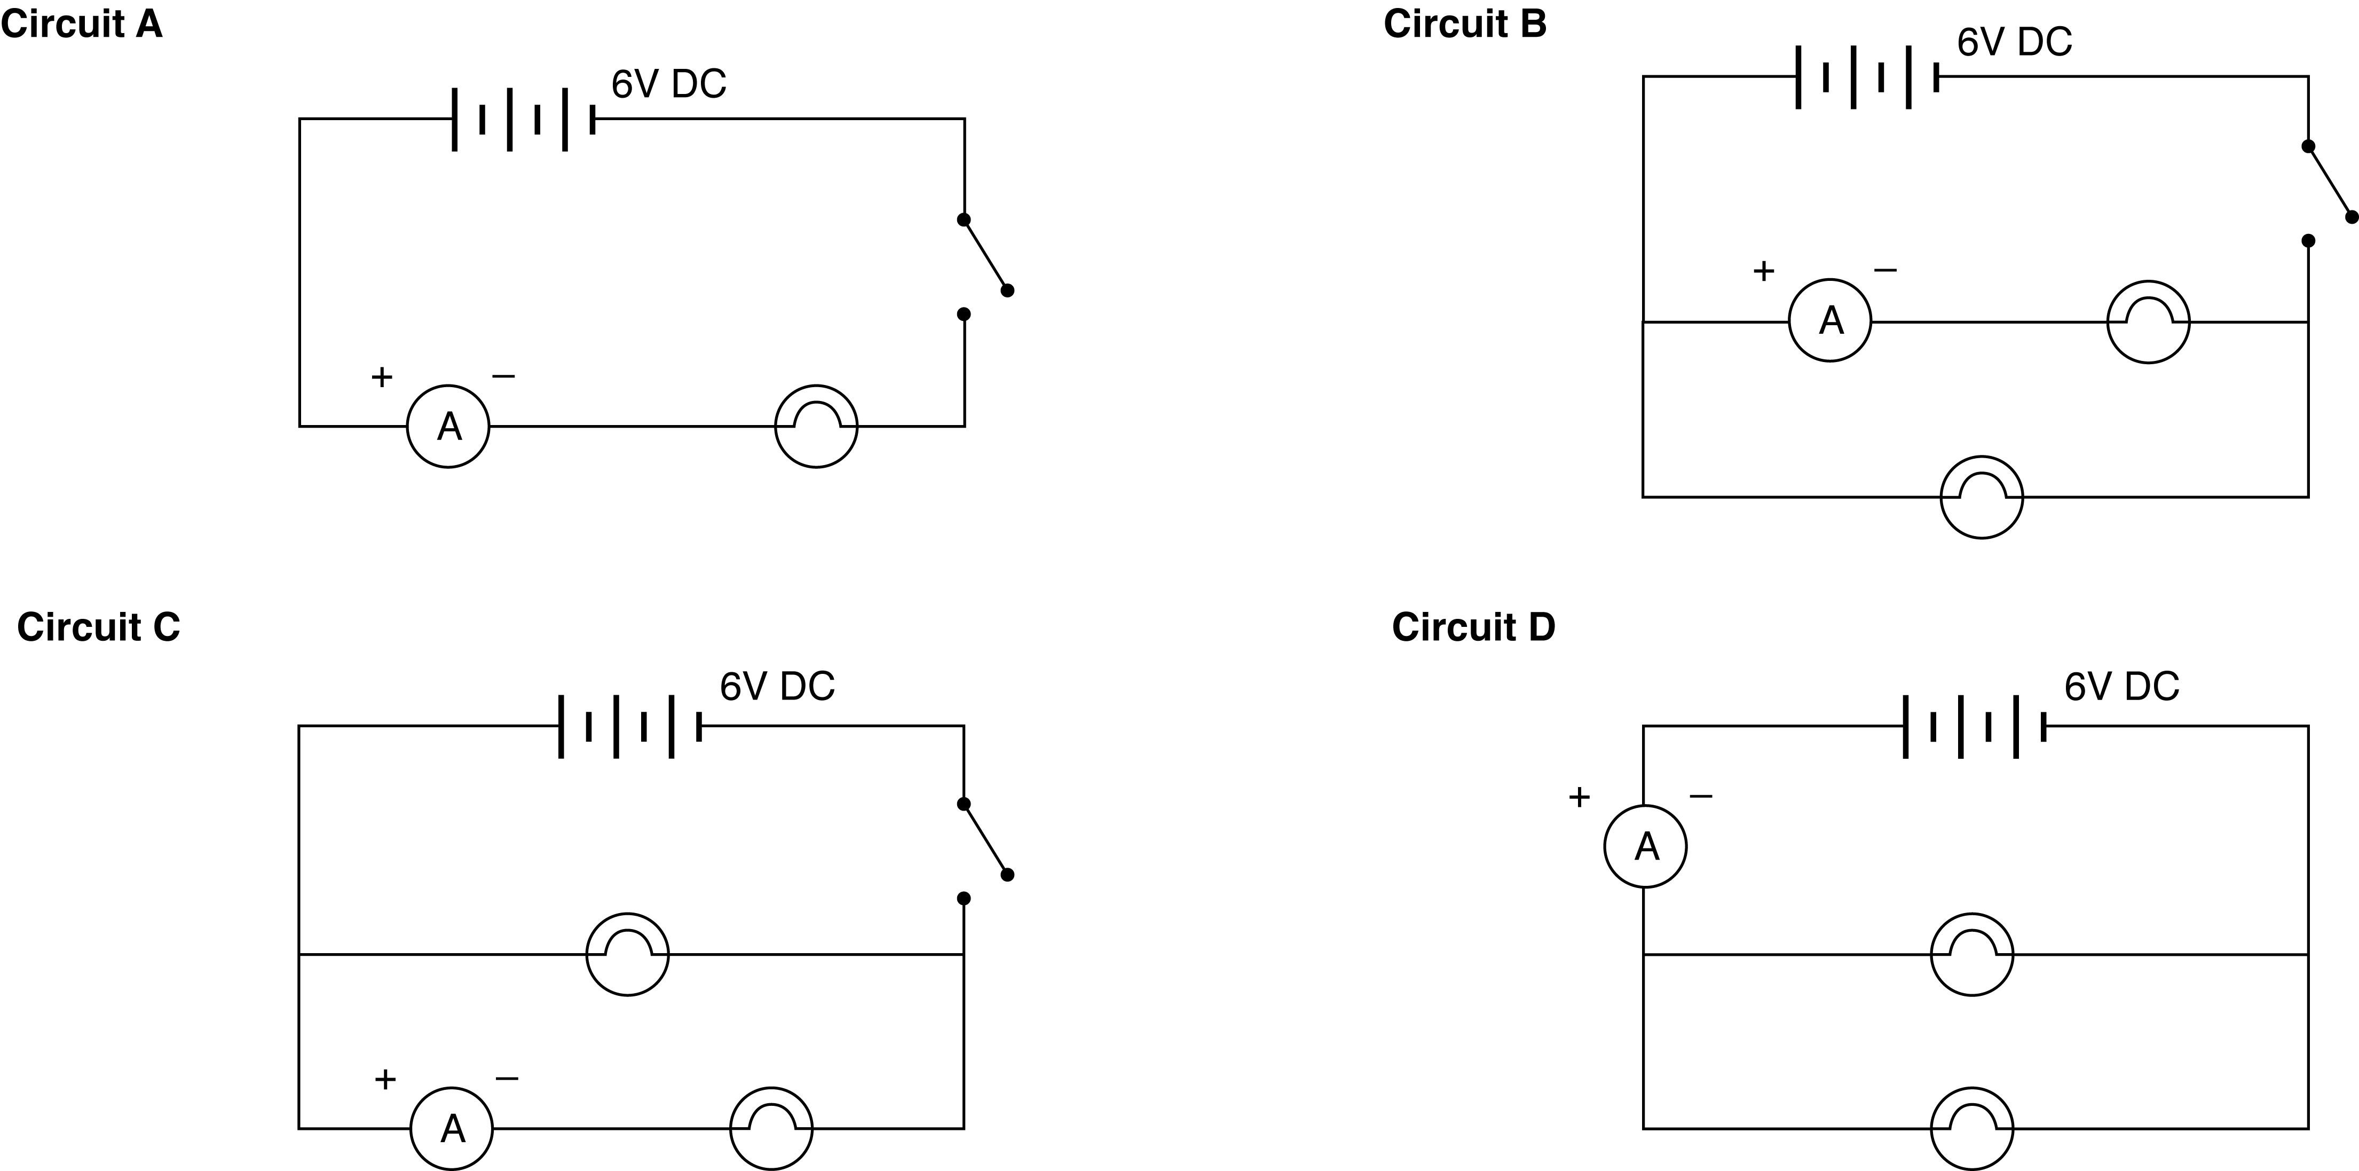

ICT
Most current sensors have a 1 A range and are suitable for this experiment.
They are generally current-protected, but take care to check the manufacturer’s specifications and use sensors with care.
Exceeding the maximum current rating will permanently damage an ammeter or sensor.
Sample rate: As only comparative values are required, the default rates of your equipment or manual sampling are suitable.
Use a digital display to view and record instantaneous values.

Using a voltmeter
Connect circuits W, X, Y and Z in turn.
Be sure that the positive terminal of the voltmeter is connected to the positive side of the circuit.
continued
21 Using electrical meters
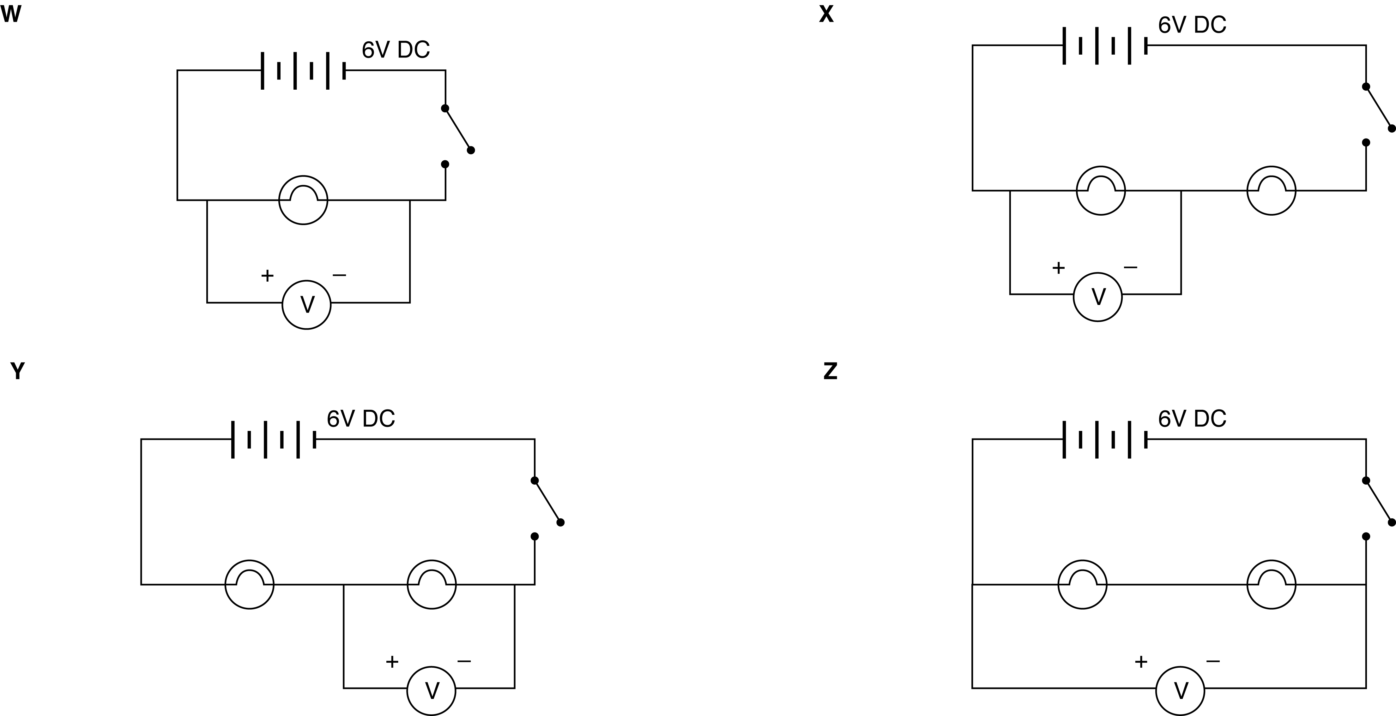

Also, ensure that the 10 V terminal of the voltmeter is used if the meter has a multiple scale.
For each circuit, close the switch and record the voltmeter reading.

ICT
Most voltage sensors have a 10 V range and are suitable for this experiment.
They are generally current-protected, but take care to check the manufacturer’s specifications and use sensors with care. Exceeding the maximum voltage rating will permanently damage a sensor or interface.
Sample rate: As only comparative values are required, the default rates of your equipment or manual sampling are suitable.
Use a digital display to view and record instantaneous values.

Note: You may find that the potential difference measured by the meter is not equal to the voltage shown on the dial of the power supply. This is because most power supplies are unregulated, which means they do not produce the same voltage for all currents drawn from them.

DATA & ANALYSIS
Tabulate all of your results for both ammeter and voltmeter.

Use your ammeter reading from Circuit A and your voltmeter reading from Circuit W to determine the resistance of the globe at its operating temperature.

CONCLUSION
Summarise your findings for each circuit.

QUESTIONS
1. What relationship appears to hold between the currents measured in Circuits B, C and D? Explain.
2. What relationship appears to hold between the potential differences measured in X, Y and Z? Explain.
3. Why must the resistance be quoted for a particular operating temperature?

